
Artificial Intelligent
LAB - 4

Fuzzy Logic and ANFIS

1. What is Fuzzy Logic?
Fuzzy Logic is an approach to computing based on degrees of truth rather than the usual true or false (1 or 0) logic used in Boolean systems.
Key Concept:
- In classical logic, a statement is either true (1) or false (0).
- In fuzzy logic, truth values range between 0 and 1.
  - Example:
    - Classical: “The water is hot” is either true or false.
    - Fuzzy: “The water is 70% hot” (truth value = 0.7).
Real-world Analogy:
- Human reasoning is fuzzy:
  - We say “it's somewhat cold,” “very fast,” or “mostly full” — these are fuzzy descriptions.

2. Why Fuzzy Logic?
- Handles uncertainty, imprecision, and approximate reasoning.
- Used where human-like reasoning is needed.
- Common in control systems, medical diagnosis, pattern recognition, etc.

3. Components of a Fuzzy Inference System (FIS)
Component | Description
Fuzzification | Converts crisp inputs to fuzzy values using membership functions
Rule Base | Set of IF-THEN rules (e.g., IF temperature is high THEN fan speed is high)
Inference Engine | Applies rules to fuzzy inputs to get fuzzy outputs
Defuzzification | Converts fuzzy outputs back to crisp values

4. Types of FIS
- Mamdani-type: Intuitive, used for control applications.
- Sugeno-type: Uses linear or constant output functions. Suitable for optimization and learning.

5. What is ANFIS? (Adaptive Neuro-Fuzzy Inference System)

ANFIS = Neural Network + Fuzzy Logic

It combines the learning capability of Neural Networks with the interpretability of Fuzzy Logic.
How ANFIS Works:
- Uses a Sugeno-type FIS.
- Learns fuzzy rules and membership function parameters from data.
- Uses hybrid learning algorithm (Least Squares + Gradient Descent).
Why Use ANFIS?
- Ideal when you have input-output data but no rule base.
- Automatically generates and tunes fuzzy systems from training data.

6. Differences: Fuzzy Logic vs ANFIS
Feature | Fuzzy Logic | ANFIS
Rule Definition | Manual | Learned from data
Learning Capability | No | Yes (via Neural Networks)
Output Type | Mamdani/Sugeno | Sugeno only
Use Case | Expert-defined systems | Data-driven modeling
Step-by-Step Guide to Download MATLAB
Steps:
- Go to: https://www.mathworks.com
- Click “Sign In” at the top right.
- Create a MathWorks account using your university email (e.g., yourname@utp.edu.my).
- After verification, log in and go to:
👉 https://www.mathworks.com/downloads/
- Click Download for Windows/Mac/Linux (it detects your OS automatically).
- Install MATLAB Installer and run it.
- During installation:
  - Choose “Log in with a MathWorks Account”
  - Choose the license provided by your university
  - Select the toolboxes you need (e.g., Fuzzy Logic Toolbox, Deep Learning Toolbox)
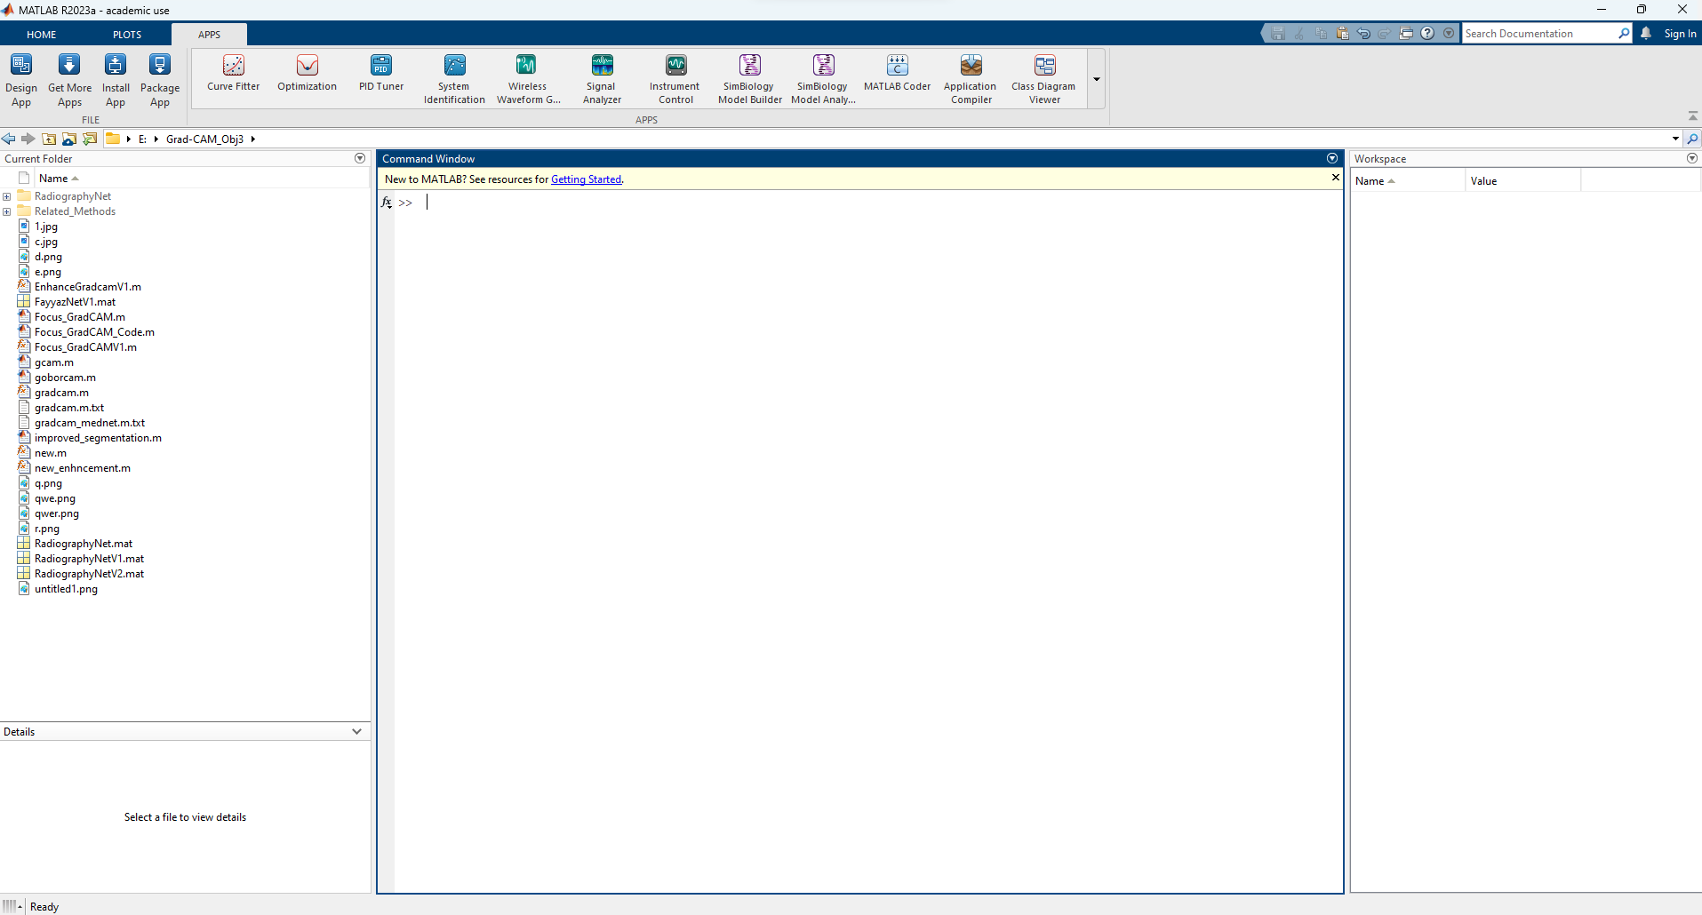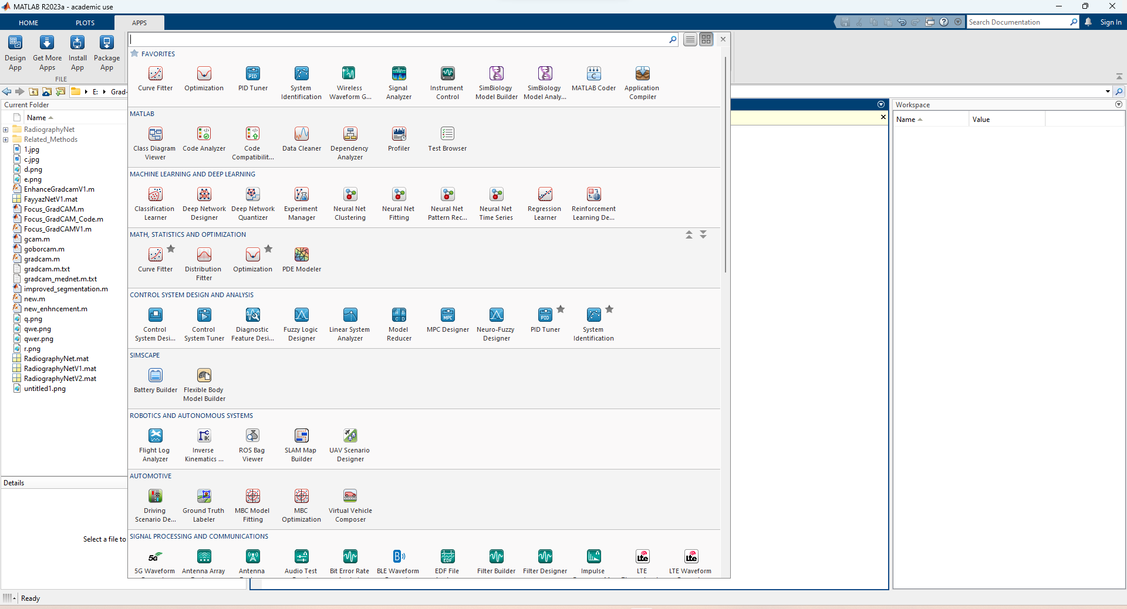

Objectives:
- Understand fuzzy logic systems and their components.
- Learn how to implement fuzzy inference systems (FIS) in MATLAB.
- Train and simulate ANFIS models with real-world datasets.

Software Requirements:
- MATLAB (with Fuzzy Logic Toolbox)

Today’s Lab
- Introduction to Fuzzy Logic
- Create a Basic FIS
- Fuzzification and Membership Functions
- Rule Definition and Evaluation
- Surface View and Rule Viewer
- FIS Using Sugeno-Type
- Load and Modify FIS
- ANFIS: Introduction and Use
- Train ANFIS on Custom Dataset
- ANFIS with Multiple Inputs
- Predict New Values with Trained ANFIS
- Export and Save FIS
- ANFIS on Medical Dataset
- ANFIS Error Analysis
- Real-time Application Use Case

Code:
%% Example 1: Create a Basic FIS
fis = mamfis('Name', 'temperatureControl');
disp(fis)

%% Example 2: Add Inputs, Outputs, and Membership Functions
fis = addInput(fis, [0 100], 'Name', 'Temperature');
fis = addMF(fis, 'Temperature', 'trimf', [0 0 50], 'Name', 'Cold');
fis = addMF(fis, 'Temperature', 'trimf', [25 50 75], 'Name', 'Warm');
fis = addMF(fis, 'Temperature', 'trimf', [50 100 100], 'Name', 'Hot');

fis = addOutput(fis, [0 10], 'Name', 'FanSpeed');
fis = addMF(fis, 'FanSpeed', 'trimf', [0 0 5], 'Name', 'Low');
fis = addMF(fis, 'FanSpeed', 'trimf', [3 5 7], 'Name', 'Medium');
fis = addMF(fis, 'FanSpeed', 'trimf', [5 10 10], 'Name', 'High');

%% Example 3: Define Fuzzy Rules (Corrected Format)
ruleList = [
1 1 1 1; % IF Cold THEN Low
2 2 1 1; % IF Warm THEN Medium
3 3 1 1 % IF Hot THEN High
];
fis = addRule(fis, ruleList);

%% Example 4: View Rules and Evaluate Output
% ruleviewer(fis);
output = evalfis(fis, 70);
disp(['Fan Speed at 70°C: ', num2str(output)]);

%% Example 5: Surface Viewer
gensurf(fis);

%% Example 6: Create a Sugeno-type FIS
fis2 = sugfis('Name','speedControl');
fis2 = addInput(fis2,[0 100],'Name','Speed');
fis2 = addOutput(fis2,[0 1],'Name','BrakeForce');

fis2 = addMF(fis2,'Speed','gaussmf',[10 20],'Name','Slow');
fis2 = addMF(fis2,'Speed','gaussmf',[10 80],'Name','Fast');
fis2 = addMF(fis2,'BrakeForce','linear',[0.01 0],'Name','Low');
fis2 = addMF(fis2,'BrakeForce','linear',[-0.01 1],'Name','High');
fis2 = addRule(fis2,[1 1 1 1; 2 2 1 1]);

%% Example 7: Load and Modify Existing FIS
fis3 = readfis('tipper');
showrule(fis3);

%% Example 8: ANFIS Training (Single Input)
data1 = [0 0; 5 2.5; 10 5; 15 7.5; 20 10];
anfisFIS1 = anfis(data1, 10);

%% Example 9: ANFIS with Two Inputs
data2 = [0 0 0; 5 2 2.5; 10 5 5; 15 7 7.5; 20 10 10];
anfisFIS2 = anfis(data2, 20);

%% Example 10: Predict with ANFIS
inputVal = [12 6];
predictedOutput = evalfis(anfisFIS2, inputVal);
disp(['Predicted Output: ', num2str(predictedOutput)]);

%% Example 11: Save and Reload Trained FIS
writefis(anfisFIS2, 'trainedFIS');
loadedFIS = readfis('trainedFIS');

%% Example 12: ANFIS on Medical Dataset (Diabetes) - Error-Free
% Load dataset (make sure diabetes.csv is in the current folder)
data3 = readmatrix('diabetes.csv'); % 8 features + 1 output (column 9)

% Normalize the data to [0, 1]
data3 = normalize(data3);

% Use only 2 features and 1 output to reduce rule complexity
dataSubset = data3(1:500, [1 2 9]); % Columns 1 & 2 as input, column 9 as output

% Train ANFIS model with 2 MFs per input
anfisFIS3 = anfis(dataSubset, 2);

%% Example 13: ANFIS Error Plot
[anfisFIS4, trainError] = anfis(dataSubset, 2); % Same data and MFs
figure;
plot(trainError);
title('ANFIS Training Error');
xlabel('Epochs');
ylabel('Error');

%% Example 14: Real-Time Application - Smart AC Control
% Training data: Temperature, Humidity → AC Intensity
data4 = [20 30 0.3;
25 40 0.5;
30 50 0.7;
35 60 0.9;
40 70 1];

% Train ANFIS with 2 MFs per input
anfisFIS5 = anfis(data4, 2);

% Evaluate new condition: 37°C and 65% humidity
result = evalfis(anfisFIS5, [37 65]);
disp(['AC Intensity for 37°C & 65% humidity: ', num2str(result)]);

